Great Western Advisory 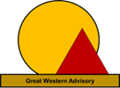
MetisMax Methodology: Training to Achieve “Better Results in Half the Time”

Every great result is based on a series of correct decisions. But how do we know we're making the best choice?
Most organizations take an unstructured and subjective approach to move from goals to results and they lack the qualitative data and analytics they need to communicate and defend their decisions.

If your organization needs to make better decisions to achieve verifiable results, then you need to learn about the MetisMax Goals to Results Methodology from Great Western Advisory.
- MetisMax systematically integrates requirements with objective and data-driven solutions to achieve any goal.
- MetisMax avoids “gut feel” decision making, minimizes risk and maximizes impact, turning the most complex goals into confident actions and outcomes.
- MetisMax can translate any strategic or operational goal into supportable decisions with precision and clarity
- MetisMax is one methodology with endless applications, and no goal is too small or complex for MetisMax
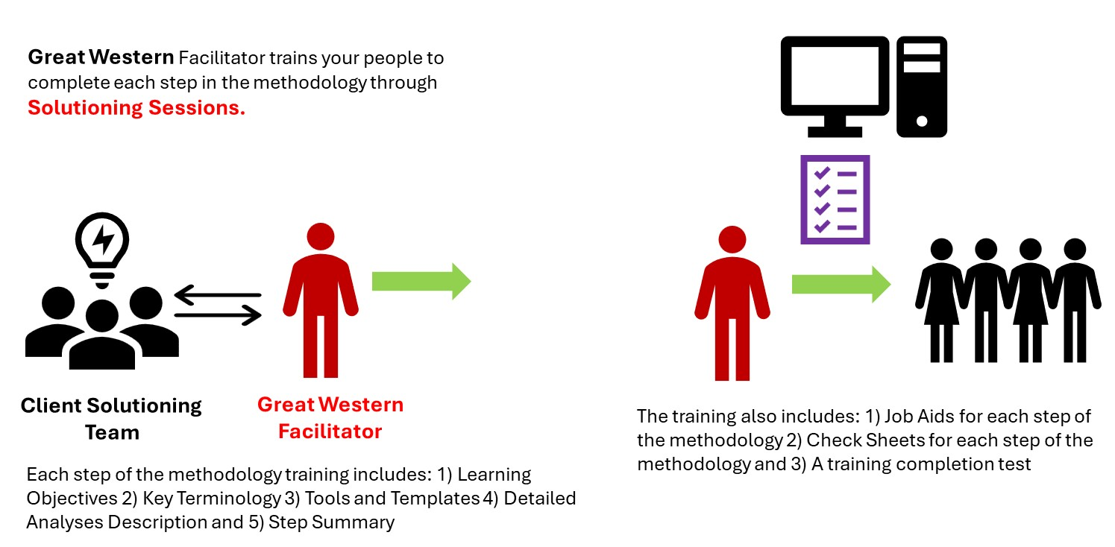
The MetisMax Methodology
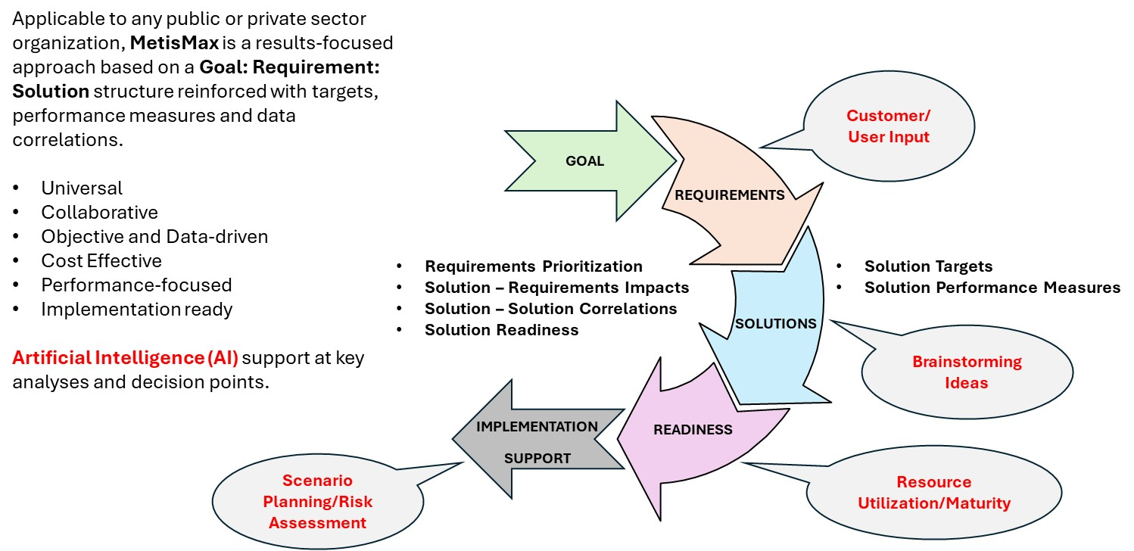
Our clients can pick from one of two training options that is right for them:
Option 1: Pre-populated Case Study Format
With this option, Great Western trains your people using a pre-populated case study. We facilitate training attendees through each step of the methodology and provide a detailed review and discussion of pre-populated analytics, templates and insights for a predetermined goal. This option is good for clients who want to complete the training within five business days.
Option 2: Client-selected Goal Format
With this option, you select a relevant goal from your own organization and training attendees apply the methodology to achieve real-world solutions to achieve the goal. With this option, Great Western works with you to properly formulate the goal statement and completes pre-training activities to properly prepare our facilitator and your training attendees to participate in the training while applying the methodology to achieve your selected goal. This option is good for clients who want to train their people while simultaneously achieving a strategic or operationally important goal. Training with this option can usually be completed within about fifteen business days with the added benefit of a set of solutions and an implementation readiness assessment to achieve your desired goal.
Copyright 2023: Great Western Advisory LLC

