Great Western Advisory 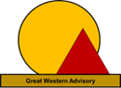
MetisMax Methodology: “Better Results in Half the Time”

Every great result is based on a series of correct decisions. But how do we know we're making the best choice?
Most organizations take an unstructured and subjective approach to move from goals to results and they lack the qualitative data and analytics they need to communicate and defend their decisions.

Great Western’s MetisMax systematically integrates customer requirements with objective and data-driven solutions to achieve any goal. Requirements to solution impacts and solution to solution correlations are done to provide a portfolio of actions with quantitative priorities. This means efficient and effective decision making to achieve any goal.
MetisMax avoids “gut feel” decision making, minimizes risk and maximizes impact, turning the most complex goals into confident actions and outcomes.
MetisMax can translate any strategic or operational goal into supportable decisions with precision and clarity.

- One methodology, endless applications.
- We bring the approach and experience to achieve desired outcomes for any type of goal, initiative, product, service processor mission area.
- Data driven, objective and results focus solutions for a process, program or the entire enterprise.
If you want results, Great Western is the right partner.
- We enable organizations to succeed at achieving verifiable results.
- No matter what the goal, from the development of a new capability, to improving an existing process or organization, to making the right acquisition or financial decisions, we are on the journey to results with you.
- With MetisMax, the methodology and tools of results achievement are in your hands.

Copyright 2023: Great Western Advisory LLC

MetisMax Methodology
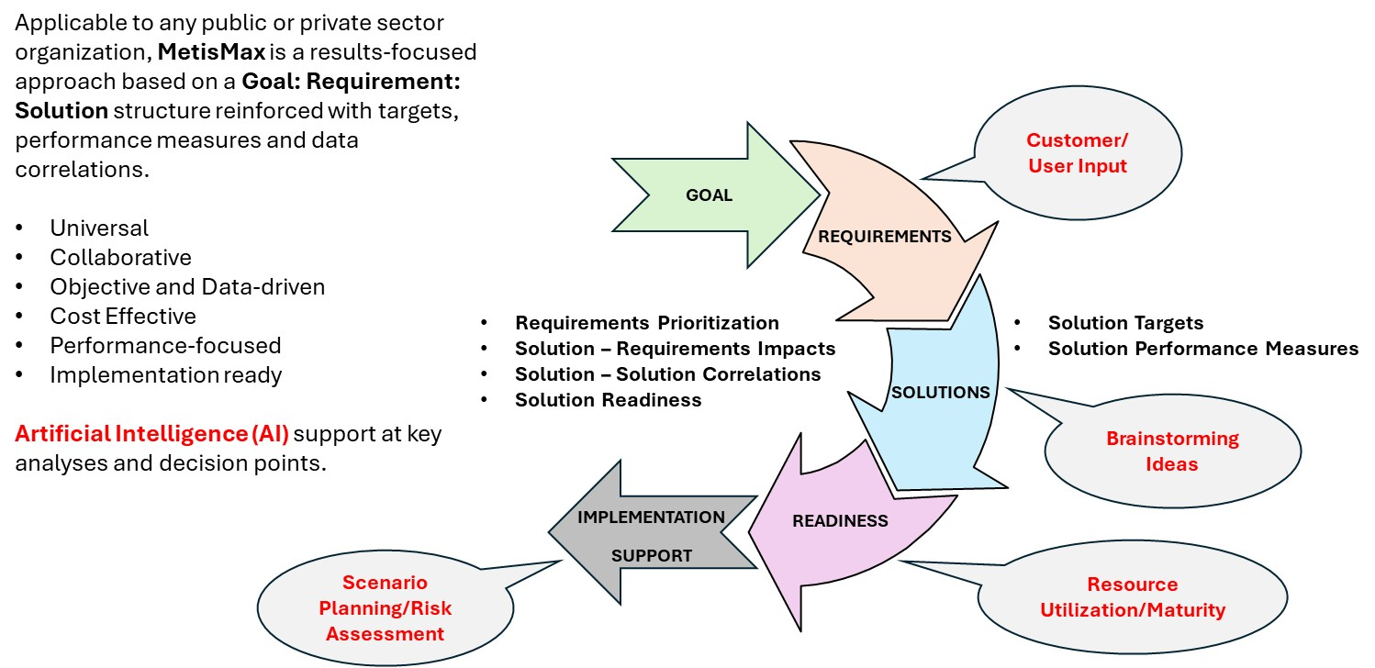

NOTE: Call Outs indicate where artificial intelligence (AI) may be applied to facilitate Solutioning Team brainstorming, idea generation and decision making.
MetisMax Methodology Steps
G | Goal – Statement of desired result or outcome
R | Requirements – “WHAT” is needed to achieve the goal
S | Solutions – “HOW” requirements will be satisfied
P | Performance – Solution targets and performance measures
I | Impacts – Solution and requirement relationships, synergies and value
R | Readiness – Availability of organizational elements to implement solutions
With the MetisMax Methodology
The organization takes an objective, structured and quantitative approach to achieve results
- Likely to achieve desired results
- Likely to meet implementation schedules
- Likely to stay on budget
- Organizational return on investment achieved

Without the MetisMax Methodology
The organization takes a subjective, scattered and qualitative approach to achieve results
- Unachieved or suboptimal results
- Extended implementation timelines
- Additional costs
- Low organizational adoption

MetisMax Methodology and Client Solutioning Teams

- Great Western leads client teams through the MetisMax methodology in facilitated sessions. We call them “Solutioning Teams.”
- We work with the client’s leadership to identify an organizationally relevant Goal or initiative to which the Solutioning Teams apply the methodology during the sessions.
- Solutioning Teams learn each step of the methodology, then immediately apply the methodology to the sample Goal or initiative to which the client’s leadership has agreed.
- At the conclusion of the methodology, the Solutioning Team produces a Final Report that can immediately be used as a roadmap to implement the desired Goal. The Report also contains specific procedures and check sheets the Teams can use to manage the individual and organization level change needed to effectively implement the Goal.
- In addition to Goal achievement, Team members and their organization, will have a repeatable methodology and the skills to apply it to develop Results for any Goal they wish to solve.

Applications for the MetisMax Goals to Results methodology include: 1) Planning, programming, budgeting and execution, 2) Agile software development, 3) Compliance assurance and risk management, 4) Process design and improvement, 5) Organizational design and right sizing, 6) Change management, 7) Product development, 8) Performance based contracting, 9) Performance measures and metrics development and 10) Strategic planning.
Copyright 2023: Great Western Advisory LLC

